# Laboratory 4

Title of the Laboratory Exercise: implement constraints and built in functions

1. Introduction and Purpose of Experiment

Constraints are the rules which are enforced on the data being stored in a table. There are constraints that can be applied to a table such as NOT NULL, UNIQUE, PRIMARY KEY and FOREIGN KEY. SQL has many built-in functions for performing calculations on data. In SQL, a built-in function is a piece for programming that takes zero or more inputs and returns a value. By doing this lab, students will be able to implement constraints and built in functions on the database.

1. Aim and Objectives

Aim

* To design and implement constraints on the data using SQL commands
* To implement built in functions in SQL

Objectives

At the end of this lab, the student will be able to

* Identify different types of constraints on the data
* Apply constraints on the data in different ways
* Implement built-in functions in SQL

1. Experimental Procedure
   * 1. Analyse the problem statement
     2. Design SQL commands using appropriate constraints
     3. Execute the SQL commands
     4. Test the executed commands
     5. Document the Results
     6. Analyse and discuss the outcomes of your experiment
2. Questions

Consider the relational schema given below.

PLAYER_DETAILS (PCode, PName, DOB, City, Score)

MATCH_DETAILS (MatchID, MatchName, PCode)

1. Apply the following constraints on the given database schema. Enter appropriate tuples to show the purpose of each constraint.
2. Not NULL
3. Default
4. Unique
5. Primary key
6. Foreign key
7. Execute the following built-in functions in SQL using Netbeans IDE
8. String functions
9. Date functions
10. Numeric functions
11. Presentation of Results

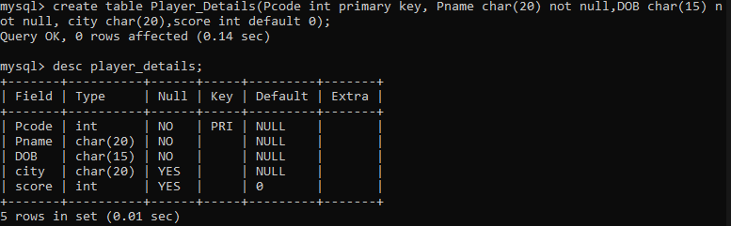

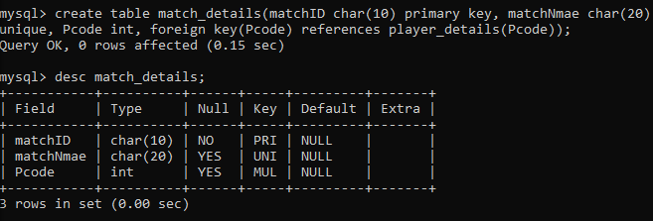

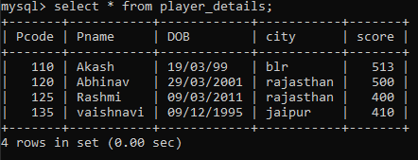 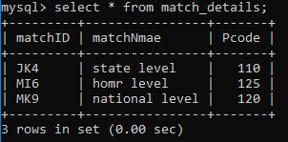



Figure Not Null

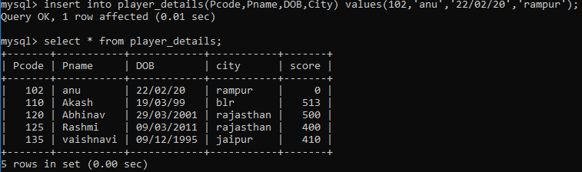

Figure Default Value

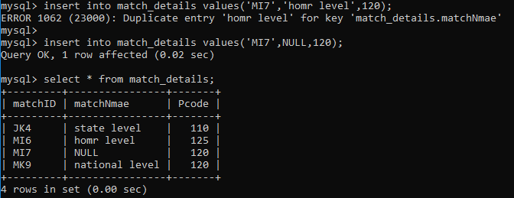

Figure Unique Key

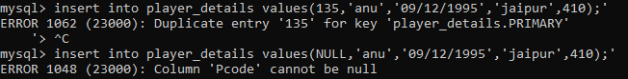

Figure Primary Key



Figure Foreign Key

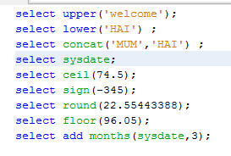

  









1. Analysis and Discussions

In the above lab given, different types of constraints are identified and defined on the data in different ways using the built-in functions in SQL. First, a database is created where two tables are to be stored that are Player_Details and Match_details. The attributes for the tables are

PLAYER_DETAILS (PCode, PName, DOB, City, Score)

MATCH_DETAILS (MatchID, MatchName, PCode)

Here, matchID and PCode are primary key. According to the problem given for the given relational schema, following constriants are to be applied that are:

1. Not NULL
2. Default
3. Unique
4. Primary key
5. Foreign key

The execution of built-in functions in SQL is done using the NetBeans IDE. The built-in functions were numeric, date and string functions where on the string concatenation was done.

1. Conclusions

Constraints are the rules which are enforced on the data being stored in a table. There are constraints that can be applied to a table such as NOT NULL, UNIQUE, PRIMARY KEY and FOREIGN KEY. SQL has many built-in functions for performing calculations on data. In SQL, a built-in function is a piece for programming that takes zero or more inputs and returns a value.